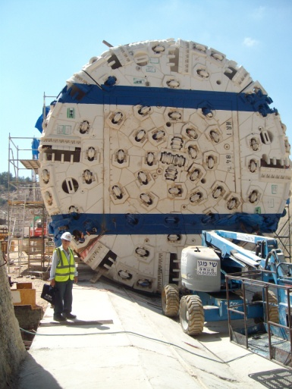 **Tunnel To Jerusalem**

**Map of the tunnel** 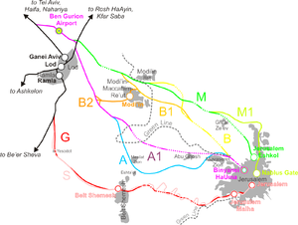

an existing motorway bridge and addition of a new bridge

|  |  |
| --- | --- |
| General Data: | |
| **Project:** | The fast Tel Aviv - Jerusalem train’s railway section Sha'ar HaGai and [Mevaseret Zion](http://en.wikipedia.org/wiki/Mevaseret_Zion) (section C) |
| **Client:** | **Shapir** in joint venture with Pizzarotti |
| **Delivery period:** | 2012 - 2014 |
| **Scope of work:** | High-speed railway line from Tel Aviv to Jerusalem   * 2 TBM-driven tunnels, length: 11,5 km each, external diameter 9,7 m, 14500 rings of 6+1 parallelogram and trapeze segments |
| **Sealing method**: | Maximum hydraulic pressure 5 bars, short rain events  Test pressure 9 bars at the worst combination of 4 mm gap and 15 mm offset  TunnelFlex 33 Plus, Rubber gaskets with 80° and 100° Soft corners |
|  | TS 33x11 (8) PLUS E 106.wmf |
| **Additional information:** | ES Rubber Ltd. | Kibbutz EIN Shemer | M.P. Hefer 38816, Israel | +972.4.637.1037 | [export@esrubber.com](mailto:export@esrubber.com) | www.esrubber.com  Dr. Werner Grabe mobile +49 174 6884223 |